Ariel Jacob Wazana

2023-04-24

Internet Programming

**(ALL .JPGs also included)**

**LOGIN PAGE:**

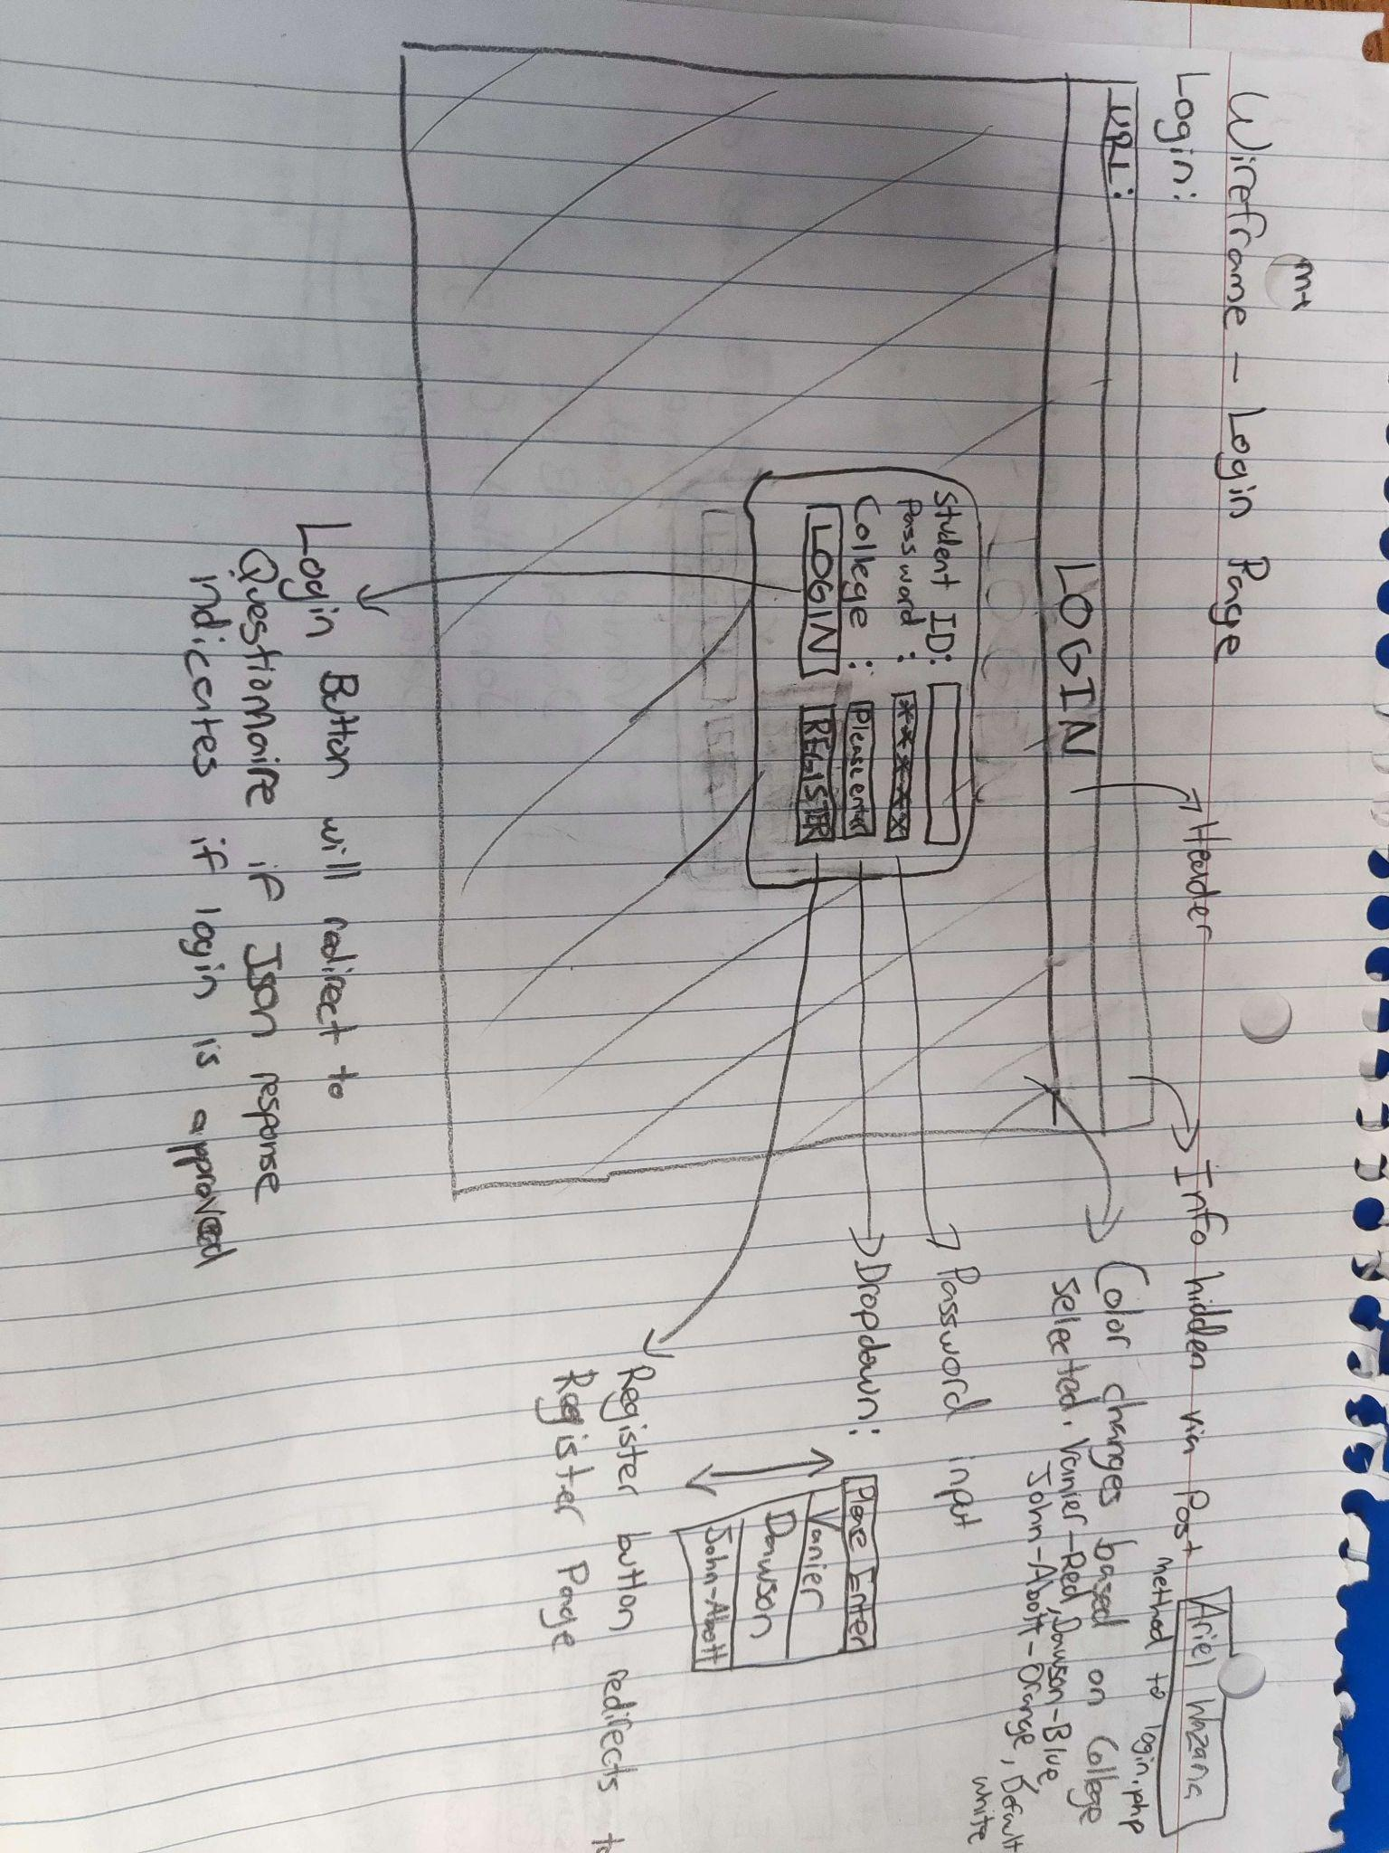

**REGISTRATION PAGE:**

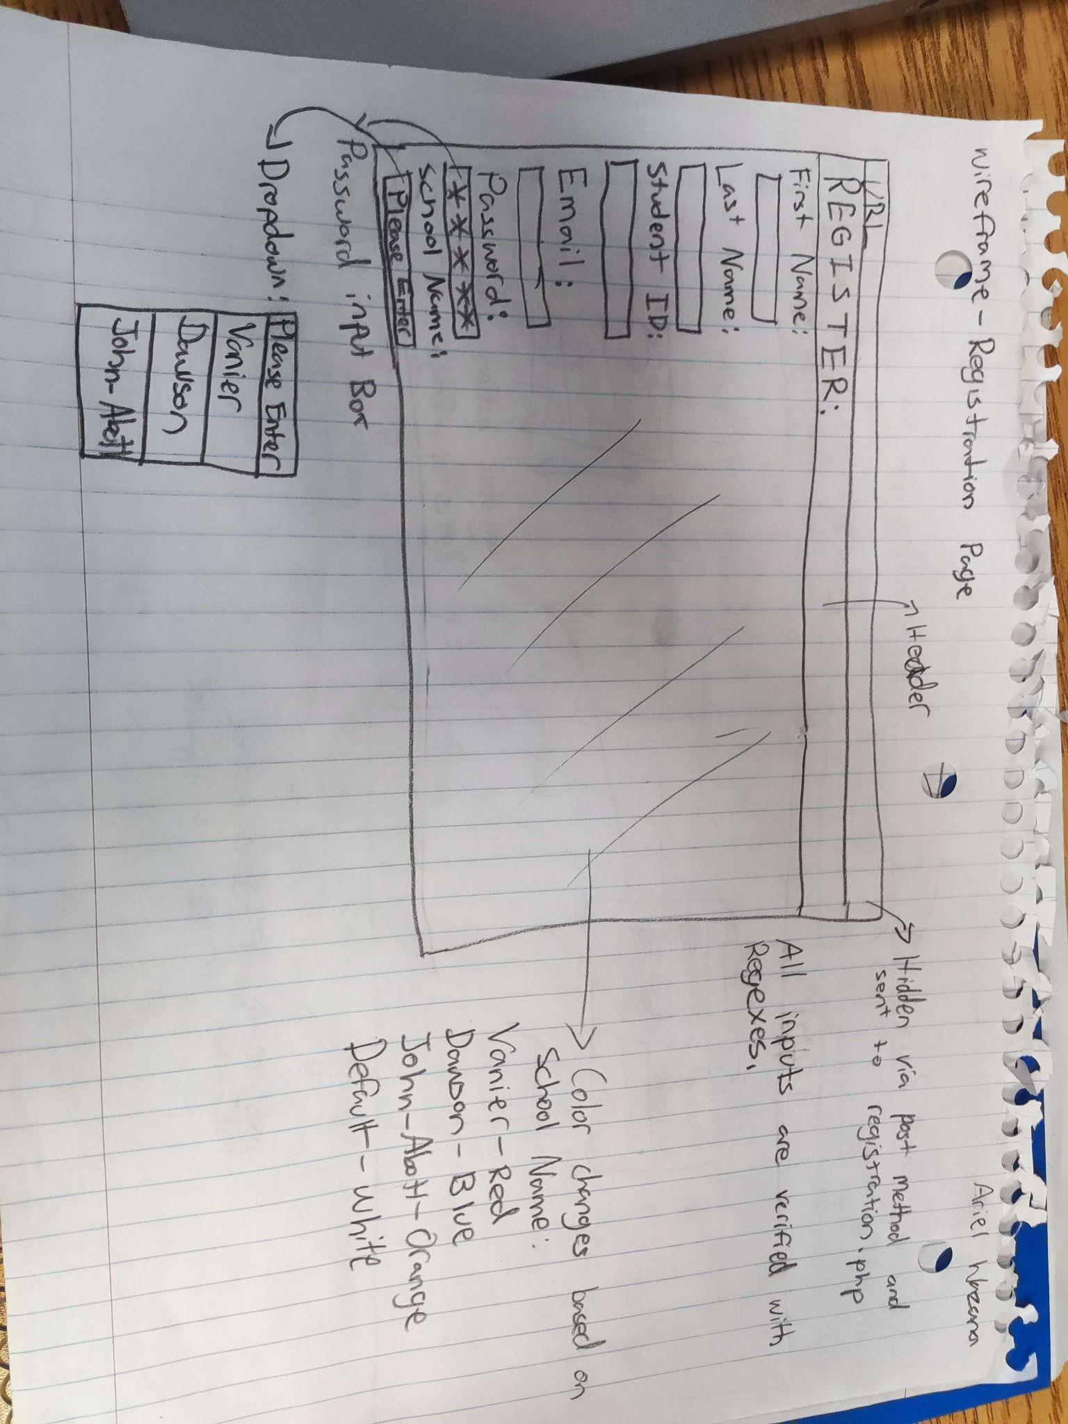

**QUESTIONNAIRE PAGE:**

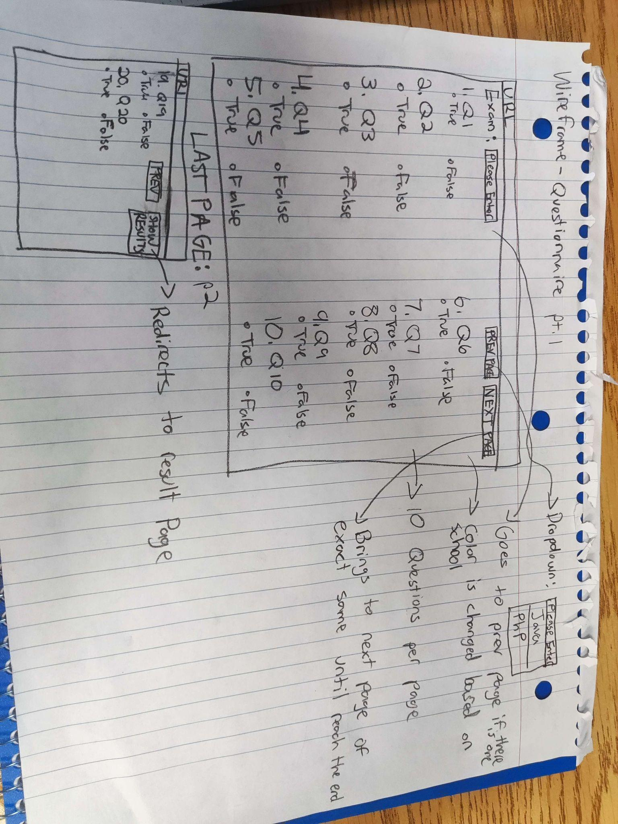

**RESULT PAGE:**

